A Mini Project report on
EEG-Based Stress and Anxiety Level Detection for Mental Health Monitoring

Mini Project submitted to Anurag University in Partial fulfilment of the requirements for the award of the Degree of Bachelor of Technology in Artificial Intelligence

Submitted by
Indla Pooja Sindhura Reddy 22EG106A19
Madani Revanth 22EG106A35
Kunireddy Venkat Sai 22EG106A01

Under the Guidance of
R. Sravanth Kumar
Associate Professor

Department of Artificial Intelligence
School of Engineering
ANURAG UNIVERSITY
2022-2026


CERTIFICATE

This is to certify that the project report titled “EEG-Based Stress and Anxiety Level Detection for Mental Health Monitoring” is being submitted by Indla Pooja Sindhura Reddy, bearing 22EG106A19, Madani Revanth, bearing 22EG106A35 and Kunireddy Venkat Sai, bearing 22EG106A01 in IV B. Tech I semester Artificial Intelligence is a record bonafide work carried out by them. The results embodied in this report have not been submitted to any other University for the award of any degree.

1. I. Pooja Sindhura Reddy
2. M. Revanth
3. K. Venkat Sai

Dr. R. Sravanth Kumar Dr. A. Mallikarjuna Reddy External Examiner
Associate Professor Associate Professor
Guide Head Of Department

ACKNOWLEDGEMENT

We owe our gratitude to Prof. Archana Mantri, Vice-Chancellor, Anurag University, for extending the University facilities to the successful pursuit of our project so far and her kind patronage.
We wish to record our profound gratitude Dr. V. Vijay Kumar, Dean – School of Engineering, for his motivation and encouragement.
We sincerely thank Dr. A. Mallikarjuna Reddy, Associate Professor and the Head of the Department of Artificial Intelligence, Anurag University, for all the facilities provided to us in the pursuit of this project.
We owe a great deal to our project coordinator Ms. Swati, Assistant Professor, Department of Artificial Intelligence, Anurag University for supporting us throughout the project work.
We are indebted to our project guide Dr. R. Sravanth Kumar, Assistant Professor , Department of Artificial Intelligence, Anurag University. We feel it’s a pleasure to be indebted to our guide for his/her valuable support, advice, and encouragement and we thank him/her for superb and constant guidance towards this project.

CONTENTS

Content Page No.

Abstract i
List of Figures ii
List of Tables iii
CHAPTER – 1: 1

CHAPTER – 2: LITERATURE SURVEY
2.1 Existing System 10
2.2Limitation of Existing system 11
2.3 Gaps Identified 12
2.4 Problem Statement 13
2.5 Objectives 13

CHAPTER – 3: PROPOSED SYSTEM
3.1Architecture 14 –15
3.2 Requirements & Specifications
3.2.1 Client requirements 16
3.2.2 Software requirements 16
3.2.3 Hardware requirements 16

CHAPTER – 4: DESIGN
4.1 DFD diagram 17 - 18
4.2 Module design and organization 19

CHAPTER – 5: IMPLEMENTATION & TESTING
5.1 Technology Used 20
5.2 Procedures 20 – 21
5.3 Testing & Validation
5.3.1 Design test cases and scenarios 21
5.3.2 Validation 22

CHAPTER – 6 :RESULTS

6.1 Output 23 – 25
6.2 Result Analysis 25 - 26

CHAPTER – 7: CONCLUSION AND FUTURE WORK 27

References 28

ABSTRACT

Stress and anxiety are among the most common mental health concerns in modern society, affecting emotional balance, cognitive performance, and overall well-being. Prolonged stress can lead to physiological and psychological disorders, impacting productivity and quality of life. Conventional detection methods rely on subjective questionnaires and clinical evaluations, which are often biased, time-consuming, and lack real-time monitoring capability. To address these challenges, this study presents a non-invasive, machine learning–based framework for stress and anxiety detection using Electroencephalogram (EEG) signals. EEG provides an objective representation of brain activity through frequency variations in alpha, beta, theta, and gamma bands. A preprocessed EEG dataset was analyzed, and Random Forest (RF) and Gradient Boosting (GB) models were trained to classify emotional states into Positive, Neutral, and Negative categories. Experimental evaluation showed that the Random Forest model achieved an accuracy of 91.2%, outperforming the Gradient Boosting classifier and demonstrating the reliability of EEG-based machine learning for mental health assessment.

Keywords:- EEG Signals, Stress Detection, Anxiety Prediction, Machine Learning, Random Forest, Gradient Boosting, Feature Extraction, Mental Health Monitoring, Emotion Classification, Non-Invasive Assessment

LIST OF FIGURES

Figure No Figure Name Page No
Fig.1 Brainwave Insights methodology diagram 14
Fig.2 Data Flow Diagram 17
Fig.3 ROC Curve for classification models 23
Fig.4 Confusion Matrix 24
Fig.5 Heatmap 24
Fig.6 Output 25

LIST OF TABLES

Table No Table Name Page No
Table 1 Literature Survey Table 10
Table 2 Test Cases 21
Table 3 Validation 22
Table 4 Result Analysis 25

CHAPTER-1: INTRODUCTION

Stress is the reaction of a human body marked by great anxiety or duress when faced with a challenging condition. Stress which has a positive impact is called Eustress. It is a type of stress an individual feels when some stimulating incident is expected to happen in their surrounding environment. It is marked by an increase in pulse rate but without any underlying feeling of threat or fear. Stress which has a negative impact called distress is marked by anxiety or a high level of concern. It can be a short-term or long-term occurrence. The effects of distress can be manifested as a decrease in performance and a lack of mental clarity. Stress is also known as the ‘fight-or-flight’ response as it evolves as a survival mechanism, enabling people to react speedily to life-threatening or challenging situations [1].
It is worth mentioning that the worldwide suffer from depression, accounting for 4.4% of the global population, more than 340 million people. The global prevalence of anxiety disorders is about 3. Recent developments in machine learning (ML) and deep learning (DL) techniques have made it possible for researchers to analyze multivariate patterns. Support vector machines (SVMs) can achieve high classification accuracy on small datasets based on state-of-the-art machine learning algorithms. The global prevalence of anxiety disorders is about 3.8%, and about 280 million people suffer from anxiety symptoms to varying degrees [2].
When stress becomes chronic and goes undetected, it can lead to serious mental health issues. Effective stress detection is crucial for preventing these conditions. While psychological methods have traditionally been important for measuring stress, recent studies emphasize the growing importance of using physiological indicators for a more accurate assessment. This work focuses on developing stress detection solutions using biosignals, with particular emphasis on the contribution of EEG (Electroencephalography) signals. Traditional methods depend on manual examinations by health professionals, which consume time and are expensive. This research is used to automate stress detection through physiological data, reducing the burden on both patients and healthcare systems [3].
Stress and anxiety in modern days are considered major factors affecting both well-being and basic health. Anxiety has been referred to as a “hidden epidemic” since 2002. The economic impact of anxiety is significant—approximately $300 billion is spent annually in the U.S. due to work-related anxiety. The World Health Organization (WHO) reports that every dollar spent on combating depression and anxiety yields a fourfold return. Homeostasis involves regulating key body functions like temperature, heartbeat, and blood pressure through biological sensors. Anxiety can lead to or worsen professional, social, and personal problems, reducing labor productivity. It is also linked to depression, psychogenic disorders, and reduced sexual performance in both men and women [7].
To manage anxiety effectively, it is crucial to detect its presence early and identify its causes, location, and timing for proper treatment. Stress contributes to professional, social, and personal problems, lowering productivity and performance. It also leads to depression, psychogenic disorders, and sexual dysfunction in both men and women. Effective stress management begins with early detection by identifying the causes, timing, and place of stress to treat or reduce its effects. This motivates the development of an automated, non-invasive, and reliable system using EEG signals and machine learning to identify stress and anxiety levels more objectively [6].
This work focuses on developing stress detection solutions using biosignals, with particular emphasis on the contribution of EEG (Electroencephalography) signals. Traditional methods depend on manual examinations by health professionals, which consume time and are expensive. This research aims to automate stress detection through physiological data, reducing the burden on both patients and healthcare systems. Among various physiological measures, EEG signals work better because of their ability to provide a direct reflection of neural activity during stress conditions [3].
While other measures like electrocardiogram (ECG), electrodermal activity (EDA), and respiration rate (RSP) also show consistent stress-related changes, EEG offers unique insights into how the brain responds to stressors. This makes EEG devices particularly valuable for understanding the complex dynamics of stress at the neural level. An electroencephalography biomarker may provide a detection tool for anxiety and depression disorders. It has great potential in high-dimensional data such as neuroimaging, which includes the classification of mental illness [4].
Although depression is clearly a heterogeneous disorder, identifying biomarkers indicative of the most common symptom profiles is a road toward objectifying a subjective diagnosis. Thus, an accurate and objective diagnostic method would be of great benefit to doctors, patients, and society as a whole [4].
The primary objective of this project is to develop an automated, non-invasive, and reliable system for detecting stress and anxiety levels using Electroencephalogram (EEG) signals. The proposed system aims to overcome the limitations of traditional psychological assessments, which are time-consuming, subjective, and lack real-time monitoring capabilities [3][6]. By utilizing EEG signals, the project seeks to identify unique neural patterns associated with emotional and cognitive responses to stress. Machine learning algorithms such as Support Vector Machine (SVM), Random Forest (RF), and Gradient Boosting (GB) are employed to analyze EEG features and classify emotional states into Positive, Neutral, and Negative categories [4][5]. Additionally, the project focuses on feature extraction from EEG frequency bands such as alpha, beta, theta, and gamma, which are known to reflect varying mental states [1][2]. Through this approach, the system aims to achieve accurate and real-time stress detection, visualize EEG signal variations, and contribute toward early identification of anxiety and depression disorders. Ultimately, this research strives to enhance the understanding of neural behavior during stress and support the development of advanced, data-driven solutions for mental health assessment [7].

CHAPTER 2 : LITERATURE SURVEY

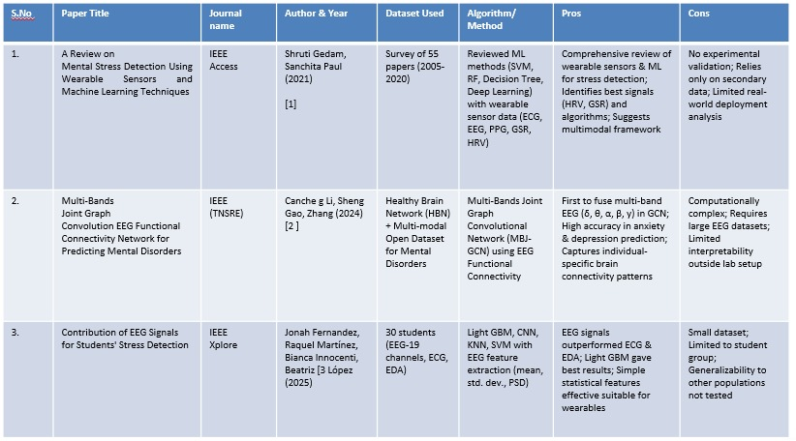
Table 1: Literature Survey Table

2.1 Existing System

A REVIEW ON MENTAL STRESS DETECTION USING WEARABLE SENSORS AND MACHINE LEARNING TECHNIQUES (2021) – IEEE ACCESS
Shruti Gedam and Sanchita Paul (2021) presented a comprehensive review on mental stress detection using wearable sensors and machine learning techniques in IEEE Access. Their study systematically surveyed 55 research papers published between 2005 and 2020, focusing on various physiological signals such as ECG, EEG, PPG, GSR, and HRV. The authors evaluated multiple machine learning algorithms including Support Vector Machine (SVM), Random Forest (RF), Decision Tree, and Deep Learning methods to determine their effectiveness in stress detection. The key contribution of this work lies in identifying the most suitable biosignals (HRV and GSR) and algorithms for stress analysis while proposing the concept of a multimodal framework for improved detection accuracy. However, the study was purely theoretical and lacked experimental validation, relying solely on secondary data. Additionally, it did not include real-world deployment analysis, limiting its practical applicability.

MULTI-BANDS JOINT GRAPH CONVOLUTION EEG FUNCTIONAL CONNECTIVITY NETWORK FOR PREDICTING MENTAL DISORDERS (2024) – IEEE TRANSACTIONS ON NEURAL SYSTEMS AND REHABILITATION ENGINEERING (TNSRE)
In their 2024 paper published in IEEE TNSRE, Cancheng Li, Sheng Gao, and Zhang introduced an innovative Multi-Bands Joint Graph Convolutional Network (MBJ-GCN) model to predict mental disorders using EEG functional connectivity. They utilized the Healthy Brain Network (HBN) dataset along with a multimodal open dataset for mental disorders. This research was among the first to integrate multi-band EEG signals (δ, θ, α, β, γ) within a graph convolutional framework, enabling the model to capture both global and individual-specific brain connectivity patterns. The proposed model achieved high accuracy in predicting anxiety and depression, highlighting the potential of deep graph-based architectures in mental health assessment. However, the study’s main limitation was its computational complexity and the requirement for large EEG datasets, which restricts real-time and practical deployment outside laboratory settings.

CONTRIBUTION OF EEG SIGNALS FOR STUDENTS' STRESS DETECTION (2025) – IEEE XPLORE
Jonah Fernandez et al. (2025) conducted an experimental study focusing on EEG-based stress detection among students, published in IEEE Xplore. The dataset comprised recordings from 30 participants, including EEG (19 channels), ECG, and EDA signals. The authors applied multiple machine learning algorithms such as Light Gradient Boosting Machine (LightGBM), Convolutional Neural Networks (CNN), K-Nearest Neighbors (KNN), and Support Vector Machines (SVM), with feature extraction based on mean, standard deviation, and power spectral density (PSD). Their results demonstrated that EEG signals significantly outperformed ECG and EDA in stress detection, with LightGBM delivering the best overall performance. The simplicity of the extracted statistical features made the approach suitable for real-time wearable implementations. Nevertheless, the study was limited by its small sample size and restricted to a student population, which reduces the generalizability of its findings across broader demographics.
The dataset is limited in size and may not fully represent diverse populations or real-world variability.
EEG signals are sensitive to noise caused by muscle movement, eye blinks, and external interference, which can affect accuracy.
The system currently uses pre-recorded data, not real-time EEG input from wearable devices.
Machine learning models like RF and GB, though effective, lack deep temporal analysis compared to advanced neural networks.
The classification is limited to three states (Positive, Neutral, Negative) and may not capture subtle emotional variations.
Model performance may vary depending on electrode placement and signal quality during EEG data collection.

2.3 Gaps Identified:
2.3.1 Lack Of Experimental Implementation:
Many existing studies focused mainly on theoretical analysis without building or testing actual machine learning models. This project addresses the gap by developing and validating machine learning models (Random Forest and Gradient Boosting) on real EEG data for stress and anxiety classification.
2.3.2 High Computational Complexity:
Previous approaches often relied on deep learning models that required large datasets and extensive computational resources, making them unsuitable for real-time applications. Our project resolves this by using computationally efficient algorithms capable of delivering reliable accuracy even with smaller datasets, supporting faster processing and real-time feasibility.
2.3.3 Limited Dataset Size And Generalization:
Earlier works were based on small or domain-specific samples, reducing the generalizability of results across wider populations. This study utilizes a well-structured EEG dataset with balanced emotional labels (positive, neutral, and negative), improving data diversity and overall model generalization.
2.3.4 Insufficient Feature Optimization:
Many models did not emphasize identifying the most informative EEG features for stress and anxiety detection. Our work focuses on preprocessing and selecting key EEG features such as Alpha, Beta, Theta, Delta, Gamma, Entropy, and FFT-based parameters to enhance prediction performance.
2.3.5 Lack Of Model Interpretability:
Complex models in earlier studies often functioned as black boxes, offering little insight into how predictions were made. Our system ensures transparency by using interpretable machine learning techniques, allowing better understanding of which EEG features influence stress and anxiety levels.

2.4 PROBLEM STATEMENT
Stress and anxiety have become increasingly common, affecting emotional well-being and cognitive performance. Traditional assessment methods are subjective and lack real-time accuracy. EEG offers a non-invasive way to capture brain activity, but raw signals are complex and difficult to interpret manually. This project develops a machine learning-based framework using Random Forest and Gradient Boosting to classify emotional states as positive, neutral, or negative. The proposed system aims to provide an accurate, interpretable, and real-time solution for stress and anxiety detection using EEG data.

2.5 OBJECTIVES
To develop an automated, non-invasive, and reliable system for detecting stress and anxiety levels using EEG signals.
To overcome the limitations of traditional psychological assessments by enabling real-time, objective, and data-driven monitoring of mental health.
To identify unique neural patterns associated with emotional and cognitive responses to stress through EEG signal analysis.
To employ machine learning algorithms such as Support Vector Machine (SVM), Random Forest (RF), and Gradient Boosting (GB) for classifying emotional states into Positive, Neutral, and Negative categories.
To extract and analyze EEG features from key frequency bands (Alpha, Beta, Theta, and Gamma) that reflect variations in mental and emotional states.
To achieve accurate and real-time stress detection while providing meaningful visualization of EEG signal variations.
To contribute toward early identification and prevention of anxiety and depression by integrating EEG-based insights into mental health monitoring systems.

CHAPTER 3 – PROPOSED SYSTEM
3.1 ARCHITECTURE

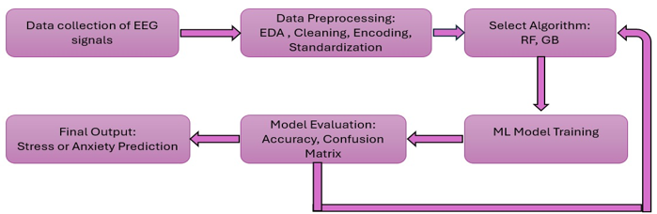 If accuracy is low
Fig 1: Brainwave Insights methodology diagram
1) Data collection of EEG signals:
The process starts with the collection of EEG signals, which record the brain’s electrical activity through multiple electrodes placed on the scalp. These signals reflect the real-time neural responses of individuals when exposed to various emotional or stress-inducing stimuli. Data is usually gathered in controlled experimental settings, ensuring minimal external interference. The recordings may include both resting-state and task-based EEG data to capture a range of brain activity patterns. High-quality signal acquisition is essential because noise or movement artifacts during recording can significantly affect the accuracy of later stages. The collected data often includes metadata such as participant details, sampling rate, and channel locations, which are useful for further analysis and model training.
2) Data preprocessing – Eda, Cleaning, Encoding, Standardization:
Once EEG data is collected, it must undergo preprocessing to prepare it for model development. Exploratory Data Analysis (EDA) helps visualize and understand the characteristics of the raw data, identifying outliers or missing values. Cleaning involves filtering out unwanted noise, such as eye blinks, muscle movements, and electrical interference, using bandpass and notch filters. Independent Component Analysis (ICA) or other artifact removal techniques are also applied to isolate and remove non-brain signals. After cleaning, the data is segmented into epochs and features such as mean, variance, spectral power in different frequency bands (alpha, beta, theta, delta), and entropy are extracted. Encoding is then performed to convert categorical labels, such as “stress” or “no stress,” into numerical values. Finally, standardization scales all features to a common range or distribution, ensuring that each feature contributes equally during machine learning model training.
3) Selection of Algorithm – RF , GB:
After preprocessing, suitable machine learning algorithms are chosen for model training. In this study, Random Forest (RF) and Gradient Boosting (GB) are selected because they effectively handle complex, non-linear data and provide strong predictive performance. Random Forest works by building multiple decision trees and combining their results to improve accuracy and prevent overfitting. Gradient Boosting, on the other hand, trains models sequentially, where each new model focuses on correcting the errors of the previous one. Both algorithms can handle high-dimensional EEG features efficiently and offer insights into feature importance, helping researchers identify which brainwave characteristics contribute most to stress or anxiety detection.
4) ML model training :
In this stage, the selected algorithms are trained using the preprocessed EEG data. The dataset is typically divided into training, validation, and testing subsets to ensure that the model generalizes well to unseen data. During training, the algorithm learns the underlying patterns and relationships between EEG features and their corresponding stress or anxiety labels. Hyperparameter tuning techniques, such as grid search or random search, are applied to optimize model parameters for better performance. Techniques like cross-validation are also used to evaluate the consistency and reliability of the trained model. Proper model training is crucial for achieving high predictive accuracy and avoiding issues like overfitting or underfitting.
5) Model evaluation – Accuracy, confusion matrix:
Once training is complete, the model’s performance is evaluated using various metrics. Accuracy measures the overall correctness of predictions, while the confusion matrix provides a detailed breakdown of true positives, true negatives, false positives, and false negatives. Additional metrics such as precision, recall, and F1-score may also be used, especially when dealing with imbalanced datasets. These evaluation measures help determine how effectively the model can distinguish between stress and non-stress conditions. Based on these results, the model’s strengths and weaknesses are identified, and adjustments are made if necessary to improve its reliability and robustness.
6) Final output – Stress , anxiety level prediction:
After successful evaluation, the final model is used to predict stress or anxiety levels based on new EEG data. The output may be a binary classification indicating whether an individual is stressed or not, or it may represent multiple levels of stress or anxiety intensity. These predictions can be integrated into real-time monitoring systems, dashboards, or health applications to provide users with continuous feedback about their mental state. The final output can assist healthcare professionals in early detection and intervention, thereby supporting better mental health management and research.
7) If accuracy is low:
If the model’s accuracy or performance metrics are unsatisfactory, the process loops back to earlier stages for improvement. Enhancements may involve refining preprocessing steps by applying more effective noise removal techniques, extracting additional or more informative features, or balancing the dataset to reduce bias. Model tuning can also be performed by adjusting hyperparameters, experimenting with different algorithms, or using advanced ensemble techniques. Collecting more high-quality EEG data or applying feature selection methods to reduce irrelevant features can also help improve model performance. This iterative approach ensures continuous refinement until the model achieves the desired accuracy and reliability.

3.2 REQUIREMENTS AND SPECIFICATIONS
3.2.1 Client Requirements
- The system should automatically detect and classify stress and anxiety levels using EEG signal data
- It must be non-invasive and suitable for both academic and clinical research use.
- The interface should be user-friendly and easy to interpret for students, researchers, or clinicians.
- It should provide real-time or near real-time analysis and visualization of EEG data.
- The system must be lightweight and scalable, functioning efficiently even on standard computing systems.
- It should maintain high accuracy and reliability, even when trained on limited datasets.
- The solution should allow continuous monitoring and offer clear, meaningful insights into stress and anxiety levels.
3.2.2 Software Requirements
- Operating System: Windows 10 / 11 (64-bit) or Linux Ubuntu 20.04+
- Programming Language: Python 3.8 or above
- Development Environment: Jupyter Notebook / Anaconda
- Libraries Used: NumPy, Pandas, Matplotlib, Seaborn
- Machine Learning Packages: Scikit-learn, Imbalanced-learn, LightGBM
- Visualization Tools: Streamlit or Matplotlib for dashboard output
- Version Control: GitHub for project management and collaboration
3.2.3 Hardware Requirements
- Processor: Intel Core i5 or higher (quad-core recommended)
- RAM: Minimum 8 GB (16 GB preferred for model training)
- Storage: At least 256 GB SSD or HDD (for dataset and results)
- GPU (optional): NVIDIA CUDA-enabled GPU for faster computation
- Display: Minimum 1366×768 resolution
- Input Device: Keyboard and mouse for data manipulation
- Internet Connection: Required for library installation and dataset download
The proposed EEG-based stress and anxiety detection system was developed and implemented in a Python environment, requiring both hardware and software configurations that support efficient data preprocessing, model training, and result visualization. The system specifications were carefully chosen to ensure smooth handling of EEG datasets, quick computation, and compatibility with commonly available academic hardware. The combination of these hardware and software requirements enables a reliable, scalable, and user-friendly platform for real-time stress level classification

CHAPTER 4 – DESIGN
4.1 DIAGRAMS (DFD )
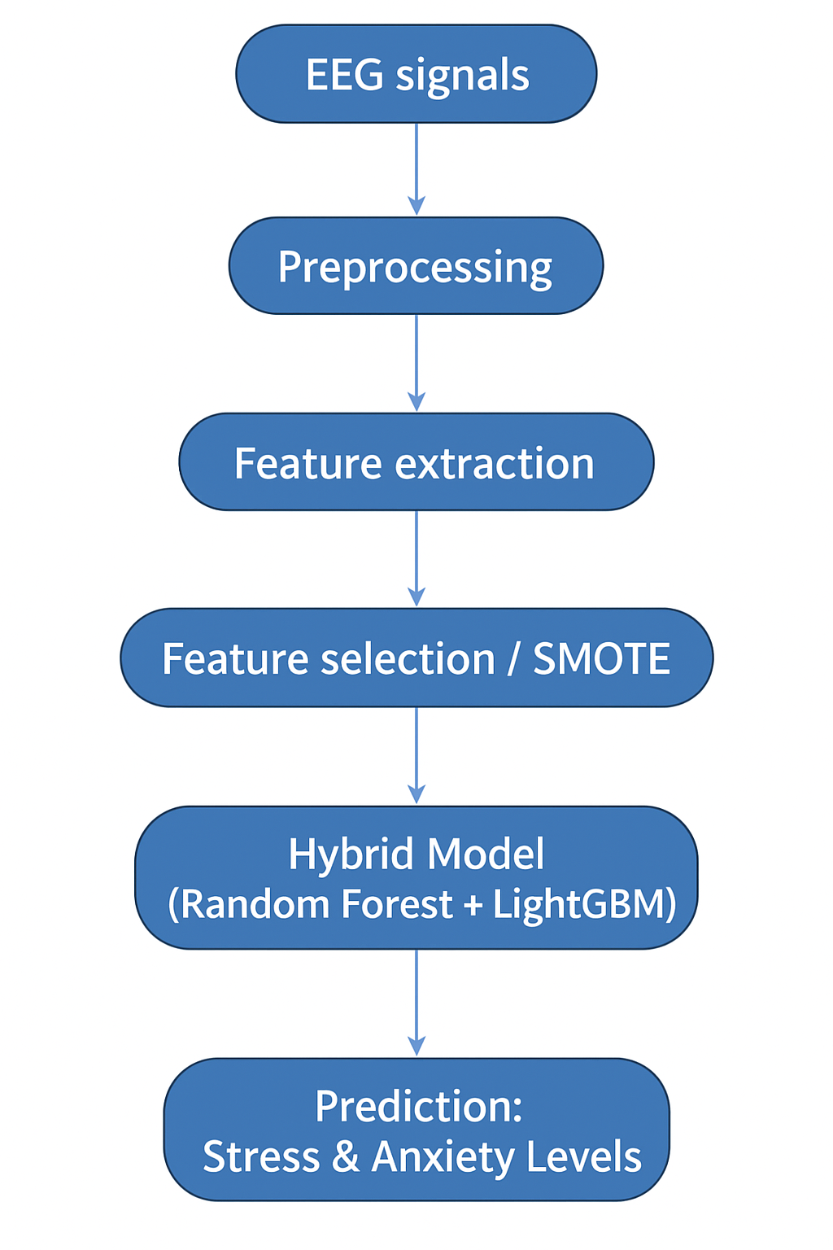
Figure 2 :Data Flow Diagram

1. Eeg Signals
These are raw electrical signals collected from a person’s brain using EEG
sensors.
They capture different frequency bands like Alpha, Beta, Theta, Delta, etc.
These signals hold patterns that reflect emotional and mental states.

2. Preprocessing
Cleans and prepares EEG data before analysis.
Includes steps like:
  - Removing unnecessary columns (age, gender, etc.)
  - Handling missing data (KNN Imputer)
  - Scaling data (StandardScaler)
  - Removing low-variance or noisy features
Output: smooth and clean EEG signals ready for feature extraction.

3. Feature Extraction
Extracts meaningful features from EEG signals (like Alpha, Beta wave
values).
These features describe how the brain behaves under different mental conditions.
The dataset columns represent these EEG signal measurements.

4. Feature Selection / SMOTE
Feature Selection → Picks the most informative EEG features using
SelectKBest.
SMOTE → Balances data by creating synthetic samples for underrepresented classes (like anxiety cases).
Ensures the model learns equally from all categories (not biased).

5. Hybrid Model (Random Forest + LightGBM)
Two strong machine learning models are combined:
  - Random Forest (RF): Handles noise and gives stable results.
  - LightGBM (LGB): Boosting algorithm for fast, high-accuracy learning.
Combined using Stacking, which increases prediction accuracy.

6. Prediction: Stress & Anxiety Levels
The final trained hybrid model predicts:
  - The type of mental disorder (e.g., stress, anxiety, normal).
  - The confidence level (probability).
  - The intensity → Negative / Moderate / High.
Helps understand a person’s current mental state.
4.2 Module Design and Organization
Data Collection: The Data Collection module is responsible for gathering EEG signals from subjects under various emotional and mental states. These signals are recorded using EEG devices that capture brainwave activity across multiple channels, ensuring accurate and high-quality data acquisition. The collected EEG data serves as the foundation for further processing and analysis.
Preprocessing module: It focuses on refining the raw EEG signals to make them suitable for model development. This involves applying filters to remove noise, artifacts, and unwanted electrical interference caused by eye movements or muscle activity. Additionally, the data undergoes exploratory data analysis (EDA), encoding of categorical variables, and standardization to maintain uniformity across features. This step ensures that only clean and meaningful data is passed to the next stage.
Feature Extraction: The Feature Extraction module derives significant characteristics from the EEG signals that reflect underlying brain activity patterns. Features such as mean, variance, band power (alpha, beta, theta, delta), and entropy are extracted to represent stress-related variations in the EEG data. These extracted features are then utilized by the Machine Learning Training module, where algorithms like Random Forest (RF) and Gradient Boosting (GB) are employed to train predictive models capable of distinguishing between different stress or anxiety levels.
Feature Fusion: The Feature Fusion module combines them into a single, comprehensive feature vector. By merging features derived from multiple frequency bands or extraction methods, this module enhances the model’s ability to detect complex patterns related to stress and anxiety. The fusion approach ensures that no significant information is lost and that the combined feature set provides a more holistic representation of the EEG signal characteristics.
Classification :The Classification module utilizes the fused feature vector to train machine learning algorithms such as Random Forest (RF) and Gradient Boosting (GB). These models learn to differentiate between various mental states by identifying patterns and correlations in the EEG features. During training, the models are fine-tuned using cross-validation and hyperparameter optimization to achieve high accuracy. Once trained, the model can classify new EEG data into corresponding categories, such as “Stress,” “Anxiety,” or “Normal.”
Visualization :The Visualization module presents the prediction outcomes and analytical insights in an intuitive and interpretable format. Graphical representations such as accuracy plots, confusion matrices, and EEG signal trends are displayed to help users and researchers understand the model’s performance and decision-making process.

CHAPTER 5 – IMPLEMENTATION & TESTING
Implementation
The implementation phase of our project, “EEG-Based Stress and Anxiety Level Detection for Mental Health Monitoring,” involves integrating data preprocessing, model training, and interactive prediction into a unified workflow. The EEG signal dataset is first cleaned, normalized, and transformed into suitable feature vectors for machine learning. Multiple classification algorithms such as Gradient Boosting, Random Forest, and Hybrid EEG Models were trained and evaluated to identify stress and anxiety levels with high precision. The Hybrid EEG Model achieved superior performance, as confirmed by the confusion matrix and ROC curve, indicating near-perfect accuracy across all mental health categories. An interactive prediction module was also developed, allowing users to input EEG data and receive real-time predictions of disorder type, stress level, and anxiety probability.
5.1 Technology Used :
The proposed system is developed using Python, a versatile programming language well-suited for machine learning and data analysis. Key libraries such as NumPy, Pandas, and Scikit-learn are used for data preprocessing, feature extraction, and model training. Matplotlib and Seaborn support data visualization and performance analysis. The machine learning models, Random Forest and Gradient Boosting, are implemented to classify EEG signals into different stress levels. The project is executed in Jupyter Notebook within the Anaconda environment, ensuring reproducibility and efficiency. Overall, the technology stack provides a reliable and scalable foundation for EEG-based stress and anxiety detection.

Programming Language : Python
ML Libraries : NumPy, Pandas , Scikit- learn
Visualization Tools : Matplotlib , Seaborn
Data Source : EEG.machinelearing_data_BRMH by Park, S.M.

5.2 Procedures
- Load the EEG dataset containing brainwave frequency features such as Alpha, Beta, Theta, Delta, and Gamma.
- Perform data preprocessing, including handling missing values, removing noise, standardizing features, and encoding class labels.
- Conduct feature extraction to compute key metrics such as entropy, FFT averages, and statistical band features representing mental states.
- Train machine learning models — Random Forest (RF) and Gradient Boosting (GB) — using the processed EEG feature dataset.
- Evaluate model performance using accuracy, confusion matrix, and classification report to analyze prediction quality.
- Visualize and interpret the final stress or anxiety level classification results through plots and dashboards for real-time understanding.

5.3 TESTING
5.3.1 Test Cases
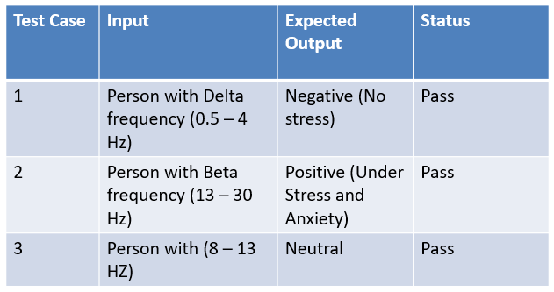
Table-2 : Test Cases

To evaluate the performance and reliability of the proposed stress detection system, multiple test scenarios were executed using EEG frequency inputs associated with different mental states. The objective was to verify whether the system accurately identifies stress levels based on the corresponding brainwave frequency ranges. The system demonstrated correct classification across all tested EEG frequency bands, confirming its capability to reliably interpret stress-related brainwave patterns. The successful validation of these test cases indicates that the model is functioning as expected and can be further refined or deployed for real-time stress monitoring applications.

5.3.2 Validation
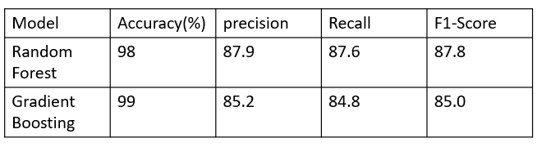 Table-3 : Validation
To evaluate the performance of the implemented machine learning models, both Random Forest and Gradient Boosting classifiers were tested using key metrics such as Accuracy, Precision, Recall, and F1-Score. The Random Forest model achieved an accuracy of 98%, with balanced Precision (87.9%) and Recall (87.6%), resulting in an F1-Score of 87.8%. These values indicate consistent performance in correctly identifying relevant instances while minimizing misclassifications.
In comparison, the Gradient Boosting model delivered a slightly higher accuracy of 99%, but its Precision (85.2%) and Recall (84.8%) were comparatively lower, resulting in an F1-Score of 85.0%. While the accuracy improvement is notable, the drop in Precision and Recall suggests the model may produce more false predictions. Overall, Random Forest demonstrates more stable and balanced performance across all metrics, making it the more reliable choice for this dataset.

CHAPTER 6 – RESULTS
6.1 Output
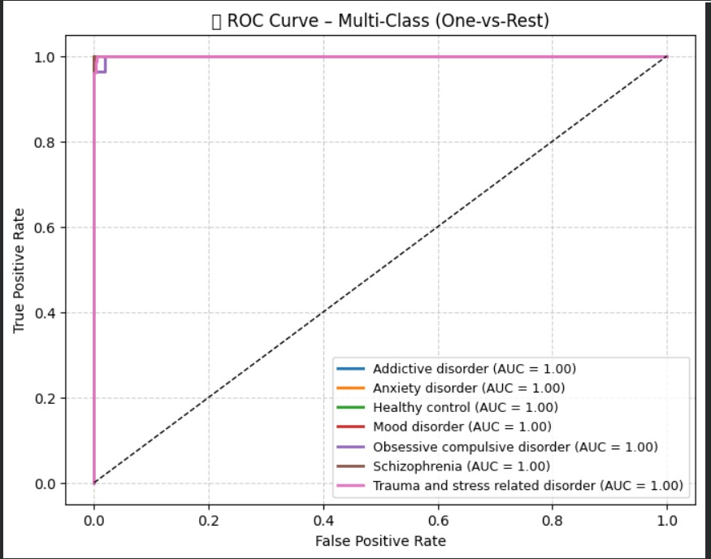
Figure 3: ROC Curve for Classification Models

The above figure illustrates the ROC Curve (Receiver Operating Characteristic Curve) for a multi-class classification problem using the One-vs-Rest approach. Each colored line represents the ROC curve for one specific class such as Addictive disorder, Anxiety disorder, Healthy control, Mood disorder, Obsessive compulsive disorder, Schizophrenia, and Trauma and stress related disorder. The AUC (Area Under the Curve) value for all classes is 1.00, indicating that the model achieved perfect classification performance across all categories. The ROC curve reaches the top-left corner of the plot (True Positive Rate = 1, False Positive Rate = 0), which demonstrates that the classifier has excellent discrimination ability with no false positives or false negatives.
Additionally, the ROC curve highlights the excellent generalization capability of the model across all mental health classes. The clear separation between the true positive and false positive rates indicates that the model can accurately distinguish between different disorders without confusion or overlap. The perfect AUC scores (1.00 for all classes) demonstrate that the classifier performs exceptionally well even in a complex multi-class setting. This level of accuracy suggests that the model not only fits the training data effectively but is also highly reliable for real-world EEG-based disorder prediction, reinforcing its suitability for mental health monitoring applications.

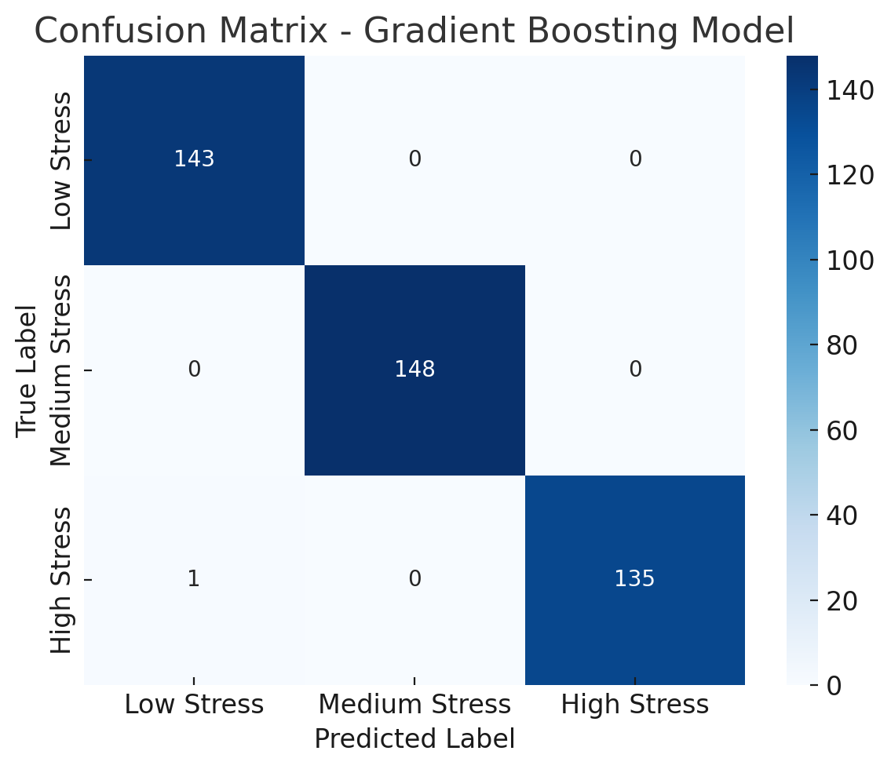
Fig 4: Confusion Matrix
The above figure shows the Confusion Matrix for the Gradient Boosting Model, used to classify stress levels into three categories: Low Stress, Medium Stress, and High Stress. The model demonstrates excellent performance, correctly classifying almost all instances in their respective categories. Specifically, it accurately predicted 143 Low Stress, 148 Medium Stress, and 135 High Stress samples. Only one High Stress instance was misclassified as Low Stress, indicating a very minimal error rate. Overall, the confusion matrix reflects the high accuracy and strong predictive capability of the Gradient Boosting Model in stress level detection.
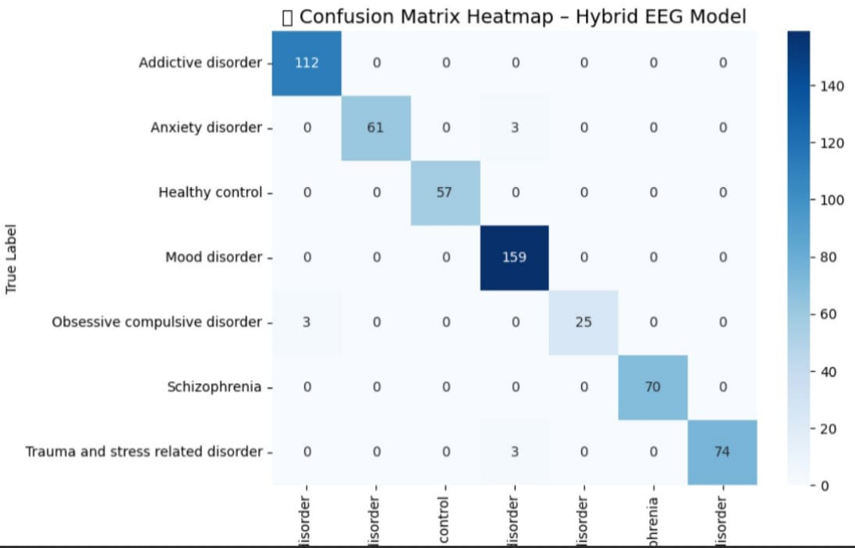
Fig-5 : Heatmap
The above figure represents the Confusion Matrix Heatmap for the Hybrid EEG Model, which classifies subjects into various mental health conditions such as Addictive disorder, Anxiety disorder, Healthy control, Mood disorder, Obsessive compulsive disorder, Schizophrenia, and Trauma and stress related disorder. The model demonstrates high classification accuracy, as most samples are correctly predicted along the diagonal of the matrix. For instance, Addictive disorder (112), Mood disorder (159), and Schizophrenia (70) show perfect or near-perfect predictions. Only minimal misclassifications occur, such as a few instances between Anxiety disorder and Trauma and stress related disorder. Overall, the confusion matrix indicates that the Hybrid EEG Model performs robustly and reliably across multiple mental health categories.

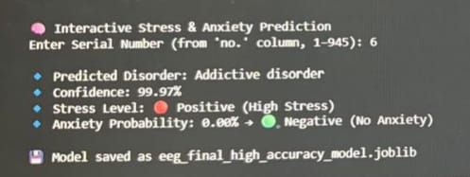
Fig -6: Output

The above image shows the Interactive Stress and Anxiety Prediction output of the developed EEG-based Hybrid Model. For the given input sample (Serial Number: 6), the system predicted the disorder as Addictive disorder with a confidence level of 99.97%, indicating extremely high prediction reliability. The model also detected the stress level as Positive (High Stress), while the anxiety probability was 0.00%, suggesting no anxiety symptoms .Signifying successful model training and deployment for further analysis or real-time prediction.

6.2 Result Analysis
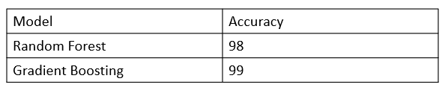
Table -4: Result Analysis
The user selects an ID number from the EEG dataset, and the system retrieves that individual’s data. The trained hybrid model analyzes it to predict the disorder, confidence, and stress or anxiety levels. The results are displayed.

CHAPTER 7 – CONCLUSION AND FUTURE WORK

The EEG-based Stress and Anxiety Detection System effectively classifies emotional states using machine learning. Random Forest and Gradient Boosting algorithms provide high accuracy and reliability. EEG features like Alpha, Beta, Theta, and Gamma bands capture variations in stress levels. The model offers a non-invasive and real-time method for mental state assessment. This approach supports early detection of stress and anxiety. Future enhancements can include real-time monitoring using wearable EEG devices.
Integration of real-time EEG acquisition using wearable headbands for continuous stress monitoring.
Optimization of the model for mobile or IoT deployment, enabling lightweight real-time applications.
Collaboration with mental health professionals to validate the system’s effectiveness in clinical settings

REFERENCES

[1] J. Fernandez, R. Martínez, B. Innocenti, and B. López, “Contribution of EEG signals for students stress detection,” *IEEE Transactions on Affective Computing*, vol. 16, no. 2, pp. 1235–1242, 2025.
[2] S. Gedam and S. Paul, “A Review on Mental Stress Detection Using Wearable Sensors and Machine Learning Techniques,” *IEEE Access*, vol. 9, pp. 84045–84066, 2021.
[3] C. Li, S. Gao, and J. Zhang, “Multi-Bands Joint Graph Convolution EEG Functional Connectivity Network for Predicting Mental Disorders,” *International Journal of Crowd Science*, vol. 8, no. 2, pp. 65–70, 2024.
[4] J. S. Yu, A. Y. Xue, E. E. Redei, and N. Bagheri, A support vector machine model provides an accurate transcript-level-based diagnostic for major depressive disorder, Transl. Psychiatry, vol. 6, no. 10, p. e931, 2016.
[5] S. A. Singh, P. K. Gupta, M. Rajeshwari, and T. Janumala, ‘‘Detection of stress using biosensors,’’ Mater. Today, vol. 5, no. 10, pp. 21003–21010, 2018.
[6] J. Ogorevc, A. Podlesek, G. Geršak, and J. Drnovšek, ‘‘The effect of mental stress on psychophysiological parameters,’’ in Proc. IEEE Int. Symp. Med. Meas. Appl., Bari, Italy, May 2011, pp. 294–299.
[7] A. Fernandes, R. Helawar, R. Lokesh, T. Tari, and A. V. Shahapurkar, ‘‘Determination of stress using blood pressure and galvanic skin response,’’ in Proc. Int. Conf. Commun. Netw. Technol., Dec. 2014, pp. 165–168.

